Question 1 - <https://docs.google.com/document/d/1cphk94OSEPAZnd363DhKuj7Tuqlt-I3F/edit?tab=t.0>

Index.html

addProduct.html

Edit Product

Delete Product

displayProduct.html

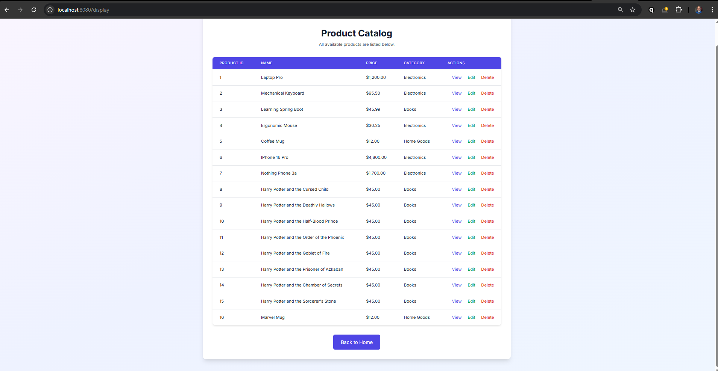

Database – H2

Select \* from PRODUCTS result

